Solve the equation. Justify each step.

1. 

Solve the equation. Determine whether the equation has one solution,   
no solution, or infinitely many solutions.

1. 
2. 
3. 

Describe the values of *c* for which the equation has no solution.

1. 

**Find the value of the variable. Then find the angle measures of the polygon**



Sum of angle measures: 

Solve the equation.

1. 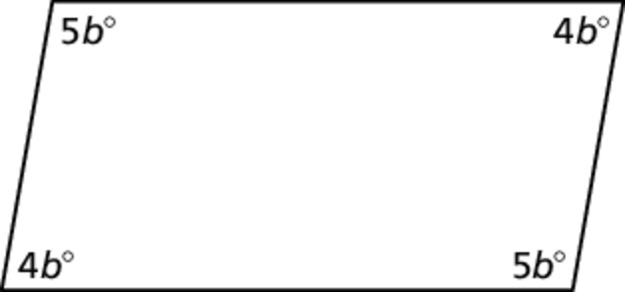
2. 
3. 

Solve the literal equation for *y*.

1. 

Solve

11. The formula for the volume of a cylinder is 

a. Solve the formula for the height *h*.

b. A cylinder has a volume of 628 cubic inches and a radius of 10 inches. What is the height of the cylinder rounded to the nearest inch?

12. The measures of two angles of a triangle are each four times the measure of the third angle. What is the measure of the third angle?

13. At a book fair, a tote bag costs $5 and books cost $3.50 each. You spend a total of $19 before taxes. How many books did you buy in addition to the tote bag?

14. For a school play, the maximum age for a youth ticket is 18 years old. The minimum age is 10 years old. Write an absolute value equation for which   
the two solutions are the minimum and maximum ages for a youth ticket.

15. Your business needs to print brochures. You call two different print shops about prices. Each print shop charges a set-up fee for preparing the brochure and a price per brochure.

a. The total cost is the same for   
each company. How many   
brochures is your business   
printing?

|  |  |  |
| --- | --- | --- |
|  | Brochure set-up fee | Price per brochure |
| Company A | $50 | $1.50 |
| Company B | $75 | $1.00 |

b. You decide to increase the   
number of brochures. From   
which company should you   
order?

Write the sentence as an inequality.

**16.** The sum of twice a number n and 8 is at most 25.

**17.** The temperature t is at least 

**Write an inequality that represents the graph**

**18**. TA: K:\BI-HighSchool\Algebra1.01\Ancillaries\production\Alg 1 AB\AB art\Ch 02\HSAlg1_ab_0200_004.eps,4/1/2014 9:23:46 AM replaced: 7/31/2016 1:31:53 PM

Solve the inequality. Graph the solution.

**19.** 

Solve the inequality.

**20.**  **21.** 

**22.**  23. 

24.  25. 

Write and graph a compound inequality that represents the numbers that   
are *NOT* solutions of the inequality represented by the graph shown.

TA: K:\BI-HighSchool\Algebra1.01\Ancillaries\production\Alg 1 AB\AB art\Ch 02\HSAlg1_ab_0200_010.eps,3/27/2014 3:21:21 PM replaced: 7/31/2016 1:31:54 PM26.

27. You need to write an essay that has at least 500 words. You have written   
285 words so far. Write and solve an inequality that represents the number   
of words *w* that you have left to write.

28. You need at least 30 cubic feet of sand to fill a sand box. Each bag contains 2.5 cubic feet of sand. Write and solve an inequality that represents the number of bags *b* that you need to buy.

29. You are planning a school carnival. The equipment costs $180 to rent. You plan to charge $4.00 per ticket. You would like to have a profit of at least $500. Write and solve an inequality that represents the number of tickets *t* that you need to sell.

30. You want to purchase a calculator for at most $115. You have saved $30 so far. You earn $7.50 per hour at your job. Write and solve an inequality that represents the number of hours *h* that you need to work.

Determine whether the relation is a function. If the relation is a function, determine whether the function is *linear* or *nonlinear*.

31. 

32. 

Find the domain and range of the function represented by the graph. Determine whether the domain is *discrete* or *continuous*.

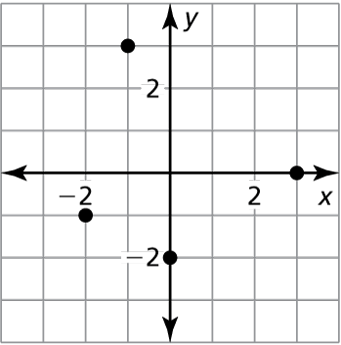33. 34.

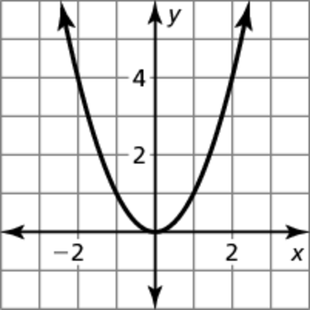

Evaluate the function when 

35. 

**Find the x- and y-intercepts of the graph of the linear equation**

36. 

37. 

The points represented by the table lie on a line. Find the slope of the line.

38. 39.

|  |  |  |  |  |
| --- | --- | --- | --- | --- |
| *x* | −5 | −3 | −1 | 1 |
| *y* | 7 | 4 | 1 | −2 |

|  |  |  |  |  |
| --- | --- | --- | --- | --- |
| *x* | 2 | 2 | 2 | 2 |
| *y* | −6 | 3 | −7 | 1 |

Graph the linear equation.

40.  41. 

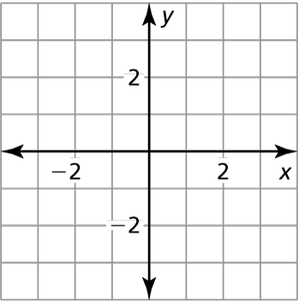

Identify the slope, *y*-intercept, and *x*-intercept of the graph of the linear equation.

42.  43.  45. 

Find the value of *x* so that 

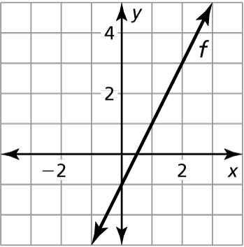45.