Name Date

Test B

Chapter

8

Graph the function. Compare the graph to the graph of 

Answers

1. See left.

2. See left.

3. See left.

4.

5.

6.

7. See left.

8. See left.

9.

10.

11.

12.

13.

14.

1.  2.  3. 

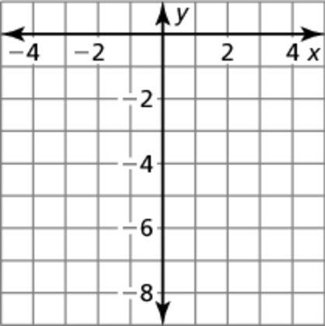 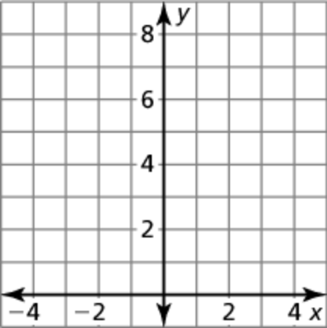 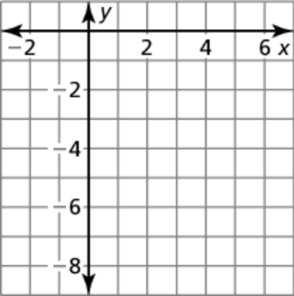

Determine whether the function is *even*, *odd*, or *neither*.

4.  5.  6. 

Use zeros to graph the function.

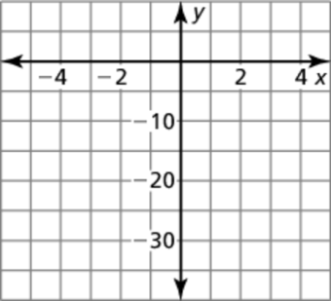 7.  8. 

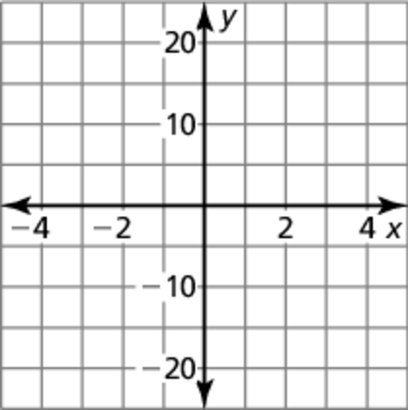

Tell whether the table of values represents a *linear*, an *exponential*, or a *quadratic* function. Then write the function.

9. 10.

|  |  |  |  |  |  |
| --- | --- | --- | --- | --- | --- |
| *x* |  |  | 0 | 1 | 2 |
| *y* | 4 | 2 | 1 | 0.5 | 0.25 |

|  |  |  |  |  |  |
| --- | --- | --- | --- | --- | --- |
| *x* |  | 0 | 1 | 2 | 3 |
| *y* | 10 | 12 | 14 | 16 | 18 |

11. 12.

|  |  |  |  |  |  |
| --- | --- | --- | --- | --- | --- |
| *x* |  | 0 | 1 | 2 | 3 |
| *y* | 5 | 3 | 5 | 11 | 21 |

|  |  |  |  |  |  |
| --- | --- | --- | --- | --- | --- |
| *x* |  | 0 | 1 | 2 | 3 |
| *y* |  |  |  |  | 4 |

Write a quadratic function in standard form whose graph satisfies the   
given conditions.

13. passes through 

14. is even and has a range of 

Name Date

Test B **(continued)**

Chapter

8

Find the zeros of the function.

Answers

15.

16.

17.

18.

19. a.

b.

c.

d.

20.

21.

22.

23.

24. a.

b.

25.

26.

15.  16. 

17.  18. 

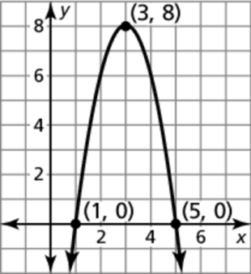 19. Consider the graph of the function *f*.

a. Find the domain, range, and zeros   
of the function.

b. Write the function *f* in standard form.

c. Compare the graph of *f* to the graph   
of 

d. Compare the graph of *f* to the graph of   


Find the vertex and axis of symmetry of the graph of the function.

20.  21. 

22.  23. 

24. The table shows the number of customers *c* that came into a store over a number of hours *t*.

a. Tell whether the data can be   
modeled by a *linear*, an *exponential*,   
or a *quadratic* function. Explain.

|  |  |  |  |  |
| --- | --- | --- | --- | --- |
| Hours, *t* | 1 | 2 | 3 | 4 |
| Customers, *c* | 3 | 9 | 19 | 33 |

b. Write a function that models the data.

Plot the points. Tell whether the points appear to represent a *linear*, an *exponential*, or a *quadratic* function.

25. 

26. 