Name Date

Test B

Chapter

1

Solve the equation. Justify each step.

Answers

1.

2.

3.

4.

5.

6.

7.

8.

9.

10.

11.

12.

13.

14.

15.

16.

17.

18.

19.

20.

1.  2. 

**Solve the equation. Determine whether the equation has *one solution*,   
*no solution*, or *infinitely many solutions*.**

3.  4. 

5.  6. 

7.  8. 

9.  10. 

Describe the value of *c* for which the equation is an identity.

11.  12**. **

**Find the value of the variable. Then find the angle measures of the polygon**.

13. 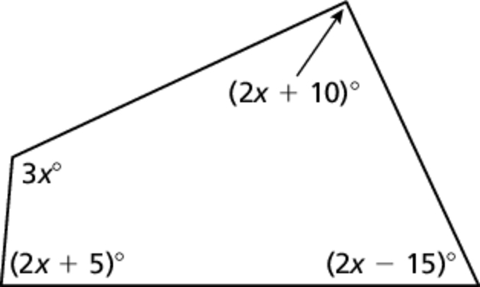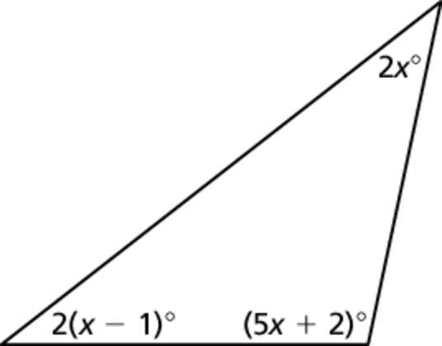 14.

Sum of angle measures:  Sum of angle measures: 

Solve the equation.

15.  16. 

17.  18. 

19.  20. 

Name Date

Test B **(continued)**

Chapter

1

Solve the literal equation for *y*.

Answers

21.

22.

23. a.

b.

24.

25.

26.

27. a.

b.

21.  22. 

23. The volume *V* of a cone is given by the formula , where *r* is   
the radius of the base and *h* is the height.

a. Solve the formula for height *h*.

b. A cone has a volume of cubic centimeters and a radius of   
6 centimeters. What is the height of the cone?

24. A rectangular garden has a length that is five less than twice the width. The garden perimeter is 50 meters. What are the dimensions of the garden?

25. A necklace chain costs $15. Beads cost $2.75 each. You spend a total of   
$28.75 on a necklace and beads before tax. How many beads did you buy   
in addition to the necklace?

26. Consider the equation . Without calculating, how do you know  
 is an extraneous solution?

27. Your soccer team wants to buy T-shirts. You call two different companies   
about prices. Each company charges a price per T-shirt and a set-up fee to   
create the team logo.

a. The total cost is the same for   
each company. How many   
T-shirts is the team buying?

|  |  |  |
| --- | --- | --- |
|  | Logo set-up fee | Price per T-Shirt |
| Company A | $50 | $15 |
| Company B | $95 | $12 |

b. A few players decide not to   
get T-shirts. Which company  
has a lower cost?