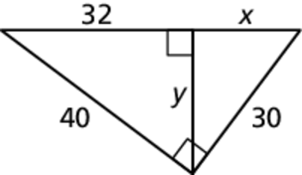Name Date

Test B

Chapter

9

Find the value of *x*. Then tell whether the side lengths form a Pythagorean triple.

Answers

1.

2.

3.

4.

5.

6.

7.

8.

9.

10.

11.

1. 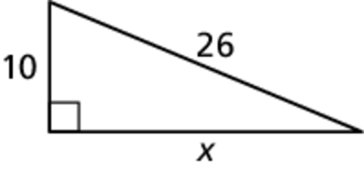 2. 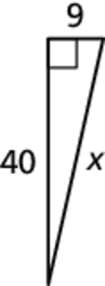 3. 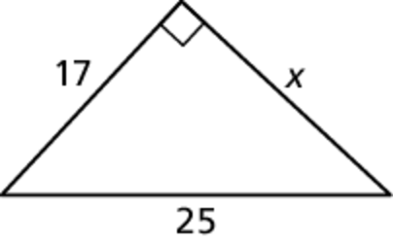

4. You fly 470 miles due west from Chicago, Illinois, to Omaha, Nebraska. You then fly 437 miles to St. Louis, Missouri. Finally, you fly 300 miles back to Chicago. Is the triangle formed by your trip *acute*, *right*, or *obtuse*? Explain your reasoning.

Find the value of *x*. Write your answer in simplest form.

5. 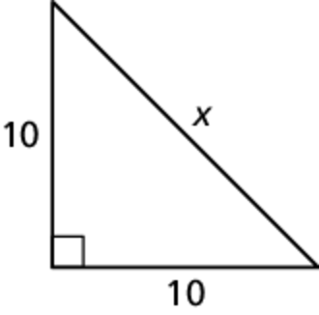6. 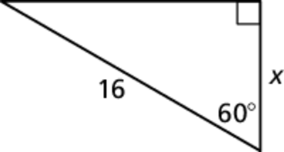 7. 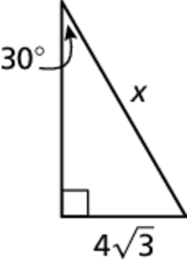

8. Your friend went on a trip to   
Kennywood Park. While there, 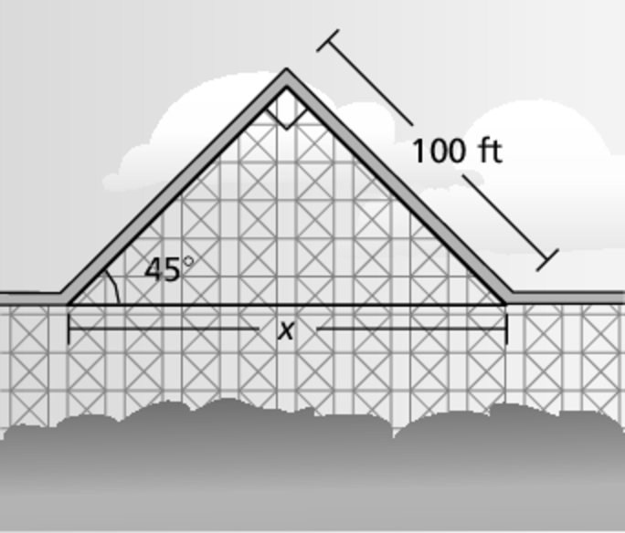  
he examined the inclined section   
of the roller-coaster track for the   
Phantom’s Revenge. He noticed   
the ramp section rose at a   
 angle with the horizontal   
section, and connected at the top   
of the hill with a segment 100 feet   
long. These pieces formed a right   
angle at the top of the hill. Find *x*,   
the length from the point of inclination   
to the bottom of the hill.

Find the values of *x* and *y*. Write your answer in simplest form.

9. 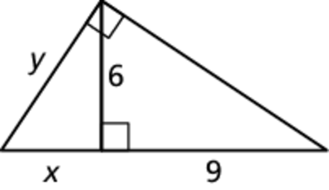 10. 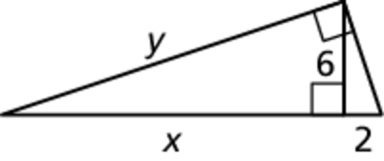 11.

Name Date

Test B **(continued)**

Chapter

9

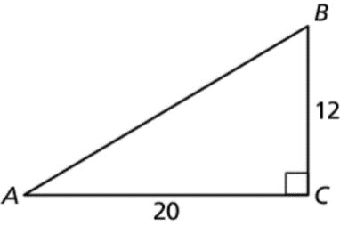Find tan *A* and tan *B*. Write each answer as a fraction and as a decimal rounded to the nearest tenth.

Answers

12.

13.

14.

15.

16.

17.

18.

19.

20.

21.

22.

23.

24.

12. tan *A* 13. tan *B*

Find the measure of each angle to  
the nearest degree.

14.  15. **

16. You look up at a angle to see the top of a building. The vertical distance from the ground to your eye is 5.5 feet and the distance from you to the building is 57 feet. Estimate the height of the building.

17. A bird sits on top of a lamppost. The angle made by the lamppost and a line from the feet of the bird to the feet of an observer standing away from the lamppost is The distance from the lamppost to the observer is 25 feet. Estimate the height of the lamppost?

Use the figure. Write your answer as a fraction and as a decimal rounded to the nearest hundredth.

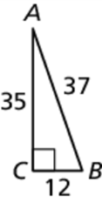 18. sin *A* 19. cos *A*

20. sin *B* 21. cos *B*

Find the values of *x* and *y*. Round your answer to the nearest tenth.

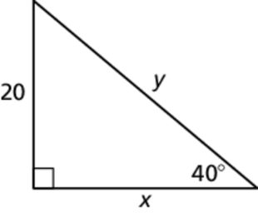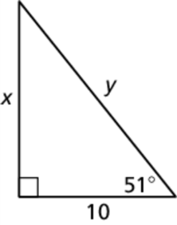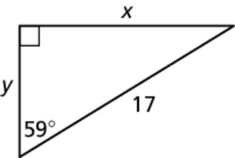 22. 23. 24.