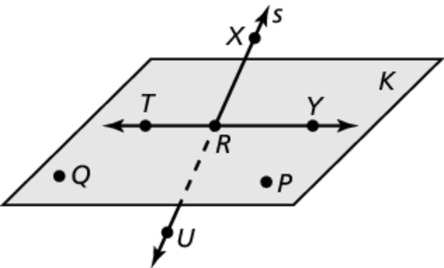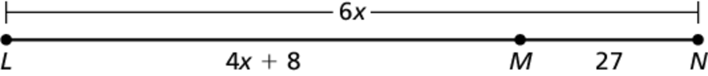Name Date

1. A map shows a section of Highway 18 that forms a straight line. A family plans to drive 480 miles on Highway 18 from Springfield to Columbia. They drive for 66 miles, and then decide they will stop halfway through their trip to rest for the night. How much farther do they need to drive before they stop for the night?

2. Point *M* is between points *L* and *N* on   and  Use the information to solve for *x*, and then find *LN*.

1. **____________**
2. **____________**
3. **____________**
4. **____________**
5. **____________**
6. **____________**
7. **____________**
8. **____________**
9. **____________**
10. **____________**

31

**Use the diagram.**

3. Give another name for line *S*.

4. Give another name for plane *K*.

5. The midpoint of  is ** One endpoint is ** Find the coordinates of endpoint *S*.

** bisects Use the diagram and the given angle measure to find the indicated angle measures.**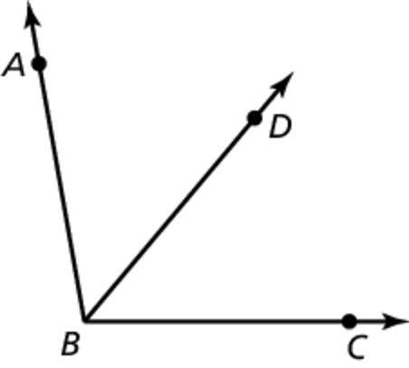

6.  Find 

7.  Find .

Find the angle measure.

**8.** is a supplement of and  Find 

**Solve the equation. Justify each step.**

Chapter

2

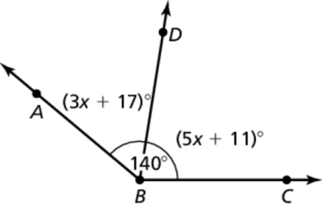 9. A gardener has 26 feet of fencing for a garden. To find the width of the rectangular garden, the gardener uses the formula where *P* is the perimeter, is the length, and *w* is the width of the rectangle. The gardener wants to fence a garden that is 8 feet long and plans on using all of the available fencing. How wide is the garden? Solve the equation for *w*, and justify each step.

10. Use the diagram to find the value of *x* and the measure of each angle.

Identify the property that justifies each statement.

**11.____________**

1. **____________**
2. **____________**
3. **X = ________**

**Y = ________**

1. **____________**
2. **____________**
3. **____________**
4. **____________**
5. **____________**
6. **____________**
7. **A’__________**

**B’__________**

**C’__________**

**D’__________**

11. If 

12. If 

13. 

Find the values of *x* and *y*.

14. 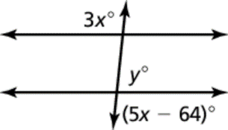

Find the value of *x* that makes 

15. 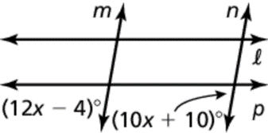

Complete the sentence.

16. The slopes of perpendicular lines are _______________.

17. Parallel lines have the _______________ slope.

**Write the equation of the line passing through the given point that is parallel to the given line.**

18. 

Write the equation of the line passing through the given point that is perpendicular to the given line.

19. 

Determine if the lines are *parallel*, *perpendicular or neither*.

20. Line *a*: 

Line *b*: 

Use the given translation to find the coordinates of the image of quadrilateral ABCD.

21. 

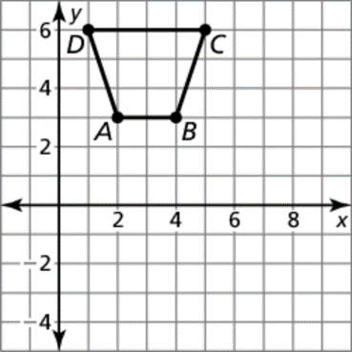

Write a rule for the translation of the preimage to the image. (Describe the transformation (or combination of transformations) that must take place.

1. **____________**

**____________**

1. **____________**
2. **____________**

**____________**

**____________**

1. **Line?_______**

**Rot? _______**

1. **____________**

**____________**

**____________**

22. 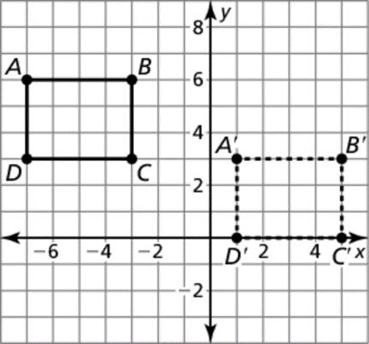

Graph the polygon with the given vertices and its image after a rotation of the given number of degrees clockwise about the origin.

23. 

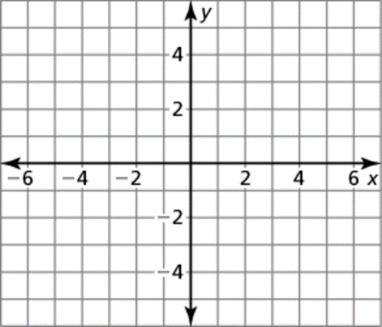

Determine whether the polygons with the given vertices are congruent or similar. Use transformations to explain your reasoning.

24. 

Determine whether the object has line symmetry and whether it has rotational symmetry. Identify all lines of symmetry and angles of rotation that map the figure into itself.

 25.

Describe a (one) congruence transformation that maps the black preimage to the grey image.

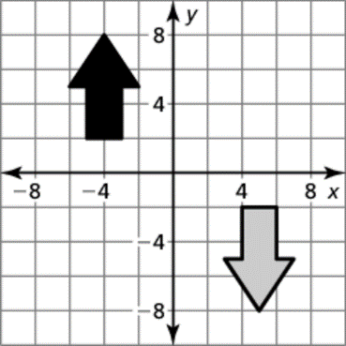 26.

27. Triangle *ABC* with vertices  is dilated using a scale factor of  What are the coordinates of the image of triangle *ABC*?

1. **A’__________**

**B’__________**

**C’__________**

1. **X =_________**

**Angles =____**

1. **X = ________**

**Angles = ____**

1. **___________**
2. **____________**

**____________**

**____________**

1. **____________**

**____________**

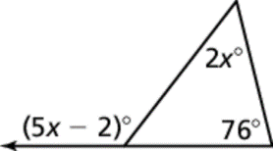

Find the measure of the angle(s).

28. 29. 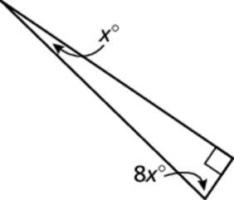

Find the value of 

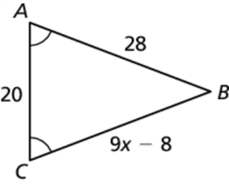 30.

Decide whether the triangles can be proven congruent by the given postulate or theorem. If not, state what information is needed.

31. 

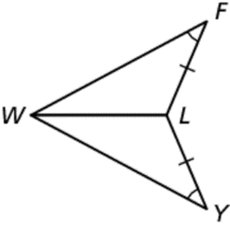

32. 

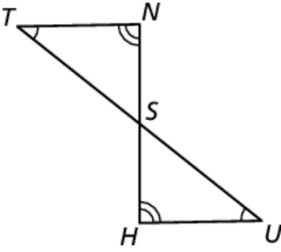

**Find the length of *AC*.**

1. **____________**
2. **____________**

**Angles =____**

1. **Y = ________**

**____**

1. **___________**
2. **____________**
3. **____________**
4. **____________**
5. **____________**

33. 

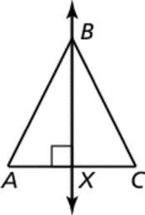

Find the indicated measure.

34. *DY* 35. 

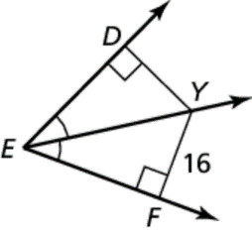 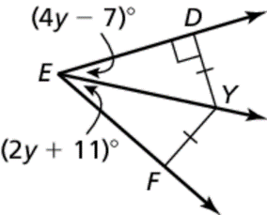

 and are angle bisectors of  Find the indicated measure.

36. ** 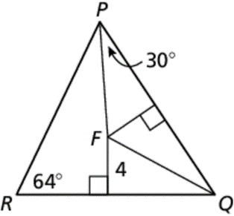

is a midsegment of  Find the value of *n*.

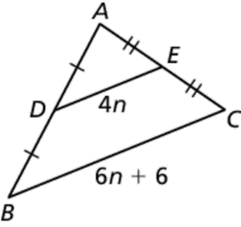37.

Describe the possible lengths of the third side of the triangle given the lengths of the other two sides.

38. 5yd, 24 yd

List the angles of  in order from least to greatest.

39. **

Copy and complete the statement with 

40. 

