Name Date

Solve the equation. Justify each step.

Algebra I Semester Exam

1. 

**Solve the equation. Determine whether the equation has *one solution*,   
*no solution*, or *infinitely many solutions*.**

2. 

3. 

4. 

Solve the equation.

6. 

7. 

8. Your business needs to print brochures. You call two different print shops about prices. Each print shop charges a set-up fee for preparing the brochure and a price per brochure.

a. The total cost is the same for   
each company. How many   
brochures is your business   
printing?

|  |  |  |
| --- | --- | --- |
|  | Brochure set-up fee | Price per brochure |
| Company A | $50 | $1.50 |
| Company B | $75 | $1.00 |

b. You decide to increase the   
number of brochures. From   
which company should you order?

Write the sentence as an inequality.

9. The product of a number *n* and 2 is no less than 14.

**Write an inequality that represents the graph.**

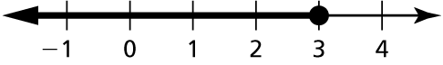 10.

Solve the inequality.

11. 

12. 

Solve the inequality.

14. 

15. You need to write an essay that has at least 700 words. You have written 246 words so far. Write and solve an inequality that represents the number of words *w* that you have left to write.

16. The cost to rent a construction crane is $1500 per day plus $250 per hour   
of use. Write and solve an inequality that can be used to determine the maximum number of hours *h* the crane can be used if the rental cost for   
one day will not exceed $5000.

Find the domain and range of the function represented by the graph. Determine whether the domain is *discrete* or *continuous*.

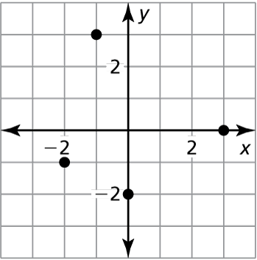 17.

Find the value of *x* so that 

18. 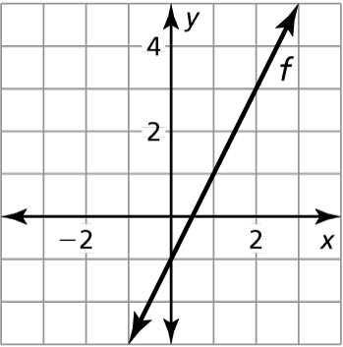

Find the *x*- and *y*-intercepts of the graph of the linear equation.

19. 

The points represented by the table lie on a line. Find the slope of the line.

|  |  |  |  |  |
| --- | --- | --- | --- | --- |
| *x* | 2 | 2 | 2 | 2 |
| *y* | −6 | 3 | −7 | 1 |

20.

Graph the linear equation.

21. 

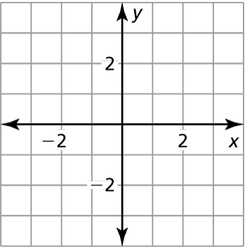

Identify the slope, *y*-intercept, and *x*-intercept of the graph of the linear equation.

22.  23. 

Write the slope-intercept form of the equation with the given characteristics.

24. 

25. 

26. 

Determine if the given lines are parallel, perpendicular, or neither.

27.  28.

Solve the system of linear equations using any method.

29.  30. 

Graph the system of linear inequalities.

31. 

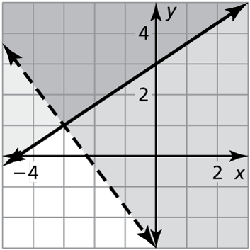 **Write a system of linear inequalities represented by the graph.**

32.

Write your answer using only positive exponents.

33.  34. 

35.  36. 

Evaluate the expression.

37. 

Solve the equation. Check your solution.

38.

Evaluate the function for the given value of *x*.

39. 