Name Date

Test B

Chapter

5

Solve the system of linear equations using any method.

Answers

1.

2.

3.

4.

5.

6.

7. See left.

8. See left.

9. See left.

10. See left.

11.

12.

1.  2.  3. 

4.  5.  6. 

Graph the inequality in a coordinate plane.

7.  8. 

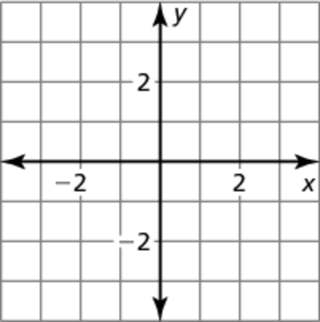 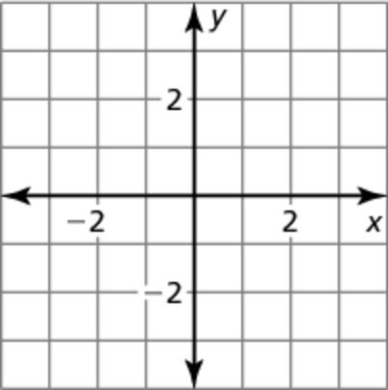

Graph the system of linear inequalities.

9.  10. 

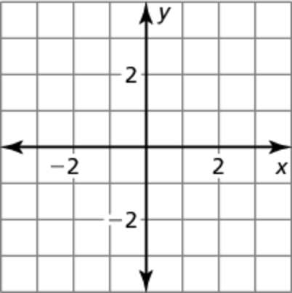 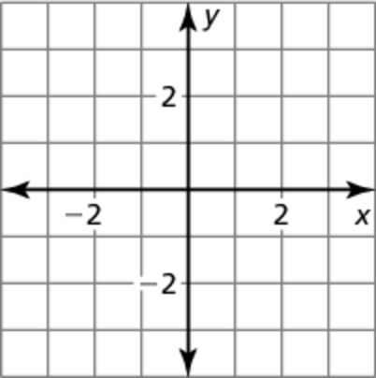

11. Write an expression that you can substitute for *x* in the top equation of the system below to solve the system by substitution.



12. You have $8.80 in pennies and nickels. You have twice as many nickels as pennies. Write a system of linear equations that models the situation. How many of each type of coin do you have?

Name Date

Test B **(continued)**

Chapter

5

Compare the slopes and *y*-intercepts of the graphs of the equations in the linear system to determine whether the system has one solution, no   
solution, or infinitely many solutions. Explain.

Answers

13.

14.

15.

16. a.

b. See left.

c.

d.

17.

18.

19.

20.

21.

13.  14.  15. 

16. You make $5 an hour in tips working at a video store and $7 an hour in tips working at a landscaping company. You must work at least 4 hours per week at the video store, and the total number of hours you work at both jobs in a week cannot be greater than 15.

a. Write a system of linear inequalities to model the number of hours that you could work at each location in a week.

b. Graph the system of linear inequalities.

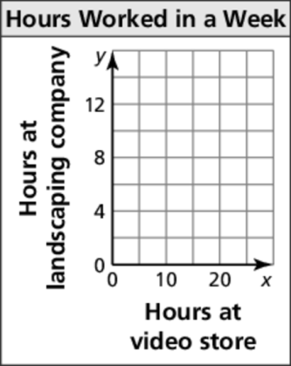

c. Write an equation that models the total tips you receive from the two jobs.

d. Identify and interpret a solution of the system.

Write a system of linear inequalities represented by the graph.

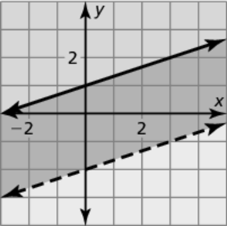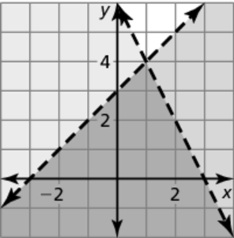 17. 18.

Solve the equation by graphing. Check your solutions.

19.  20.  21. 